**DATA SCIENCE PCA LAB 5**

**Roll no: 20K-0409**

**Screen Shots**

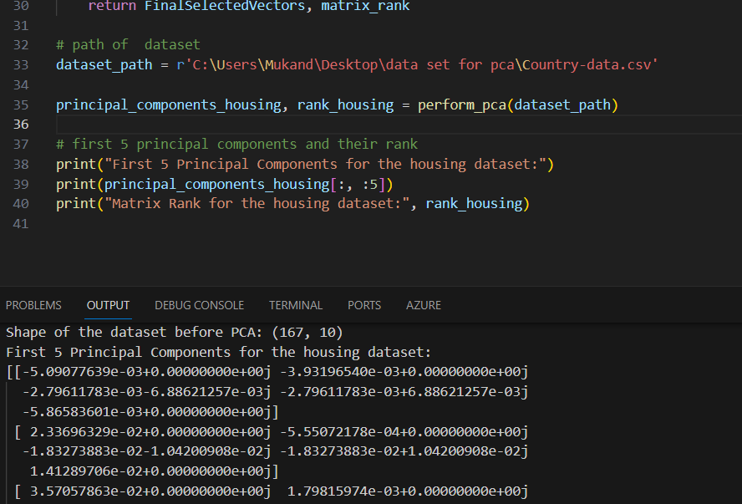

**DATAset#1**

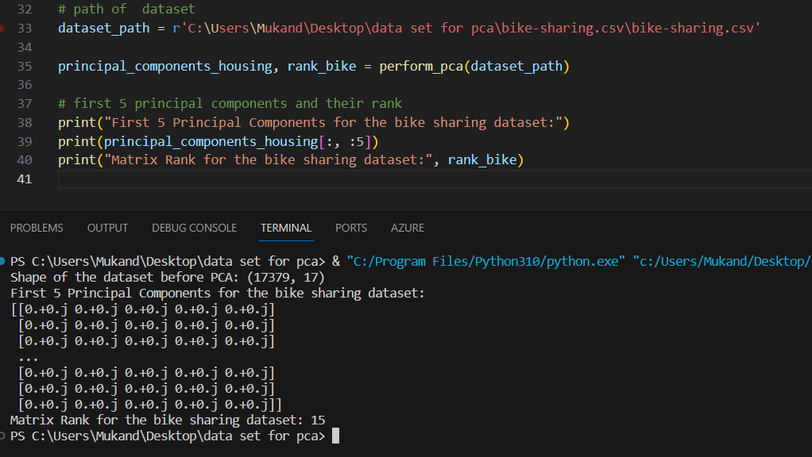

**DATAset#2**

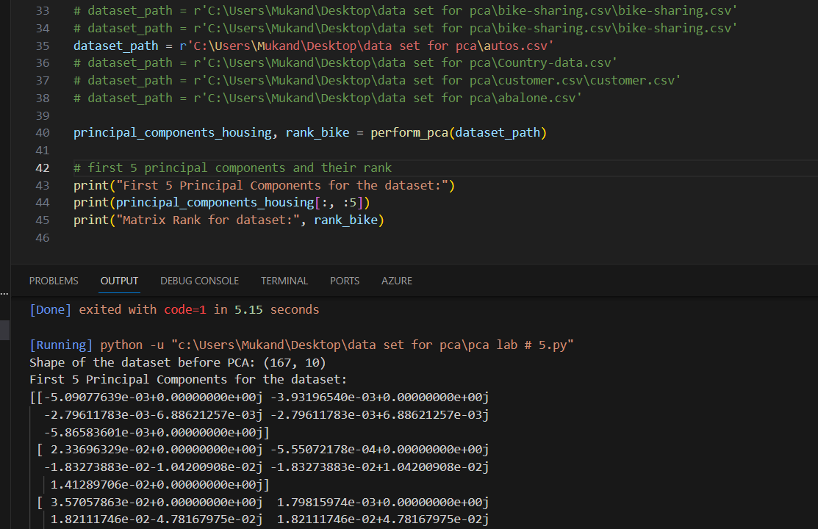

**DataSet # 3**

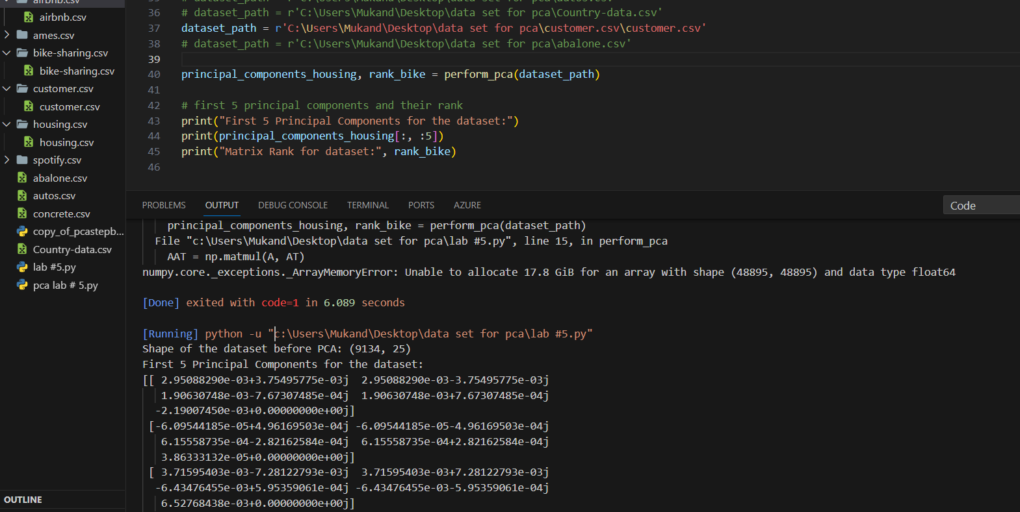

**DATAset#4**

**DataSet #5**